Insert School Logo

Semester One Examination 2018

Question/Answer Booklet

MATHEMATICS
METHODS UNIT 1

Section Two:
Calculator-assumed

Student Name: _____________________________________

Teacher’s Name: _____________________________________

Time allowed for this section
Reading time before commencing work: ten minutes
Working time for paper: one hundred minutes

Material required/recommended for this section

To be provided by the supervisor
This Question/Answer booklet
Formula Sheet (retained from Section One)

To be provided by the candidate
Standard items: pens(blue/black preferred), pencils(including coloured), sharpener, correction tape/fluid, erasers, ruler, highlighters

Special Items: drawing instruments, templates, notes on two unfolded sheets of A4 paper, and up to three calculators approved for use in the WACE examinations.

Important note to candidates
No other items may be taken into the examination room. It is your responsibility to ensure that you do not have any unauthorised notes or other items of a non-personal nature in the examination room. If you have any unauthorised material with you, hand it to the supervisor before reading any further.

Structure of this paper

 | Number of questions available | Number of questions to be attempted | Suggested working time (minutes) | Marks available | %
Section One  Calculator—free | 9 | 9 | 50 | 52 | 35
Section Two  Calculator—assumed | 13 | 13 | 100 | 98 | 65
 |  |  |  | 150 | 100

Instructions to candidates

- The rules for the conduct of Western Australian external examinations are detailed in the Year 12 Information Handbook 2018. Sitting this examination implies that you agree to abide by these rules.

- Answer the questions according to the following instructions.

Section Two: Write answers in this Question/Answer Booklet. Answer all questions.

Show all your working clearly. Your working should be in sufficient detail to allow your
answers to be checked readily and for marks to be awarded for reasoning. Incorrect
answers given without supporting reasoning cannot be allocated any marks. For any
question or part question worth more than two marks, valid working or justification is required to receive full marks. If you repeat an answer to any question, ensure that you cancel the answer you do not wish to have marked.

It is recommended that you do not use pencil, except in diagrams.

- You must be careful to confine your responses to the specific questions asked and to follow any instructions that are specific to a particular question.

- Spare pages are included at the end of this booklet. They can be used for planning your responses and/or as additional space if required to continue an answer.
- Planning: If you use the spare pages for planning, indicate this clearly at the top of the page.
- Continuing an answer: If you need to use the space to continue an answer, indicate in the original answer space where the answer is continued, i.e. give the page number. Fill in the number of the question that you are continuing to answer at the top of the page.

- The Formula Sheet is not handed in with your Question/Answer Booklet.

Section Two: Calculator–assumed 65% (98 marks)

This section has thirteen (13) questions. Attempt all questions. Write your answers in the spaces provided.

Spare pages are included at the end of this booklet. They can be used for planning your responses and/or as additional space if required to continue an answer.

- Planning: If you use the spare pages for planning, indicate this clearly at the top of the page.
- Continuing an answer: If you need to use the space to continue an answer, indicate in the
original answer space where the answer is continued, i.e. give the page number. Fill in the
number of the question(s) that you are continuing to answer at the top of the page.

Working time: 100 minutes

Question 10 (7 marks)

The current A (amperes), varies inversely to the resistance R (ohms) in an electric circuit.
When the resistance is 12 ohms, the current is 0.5 amperes.

(a) State the constant of proportionality. (1 mark)

(b) Calculate the resistance if the current is 5 amperes. (1 mark)

(c) Determine the effect on R if A is increased by 35%. (2 marks)

(d) Draw the graph of this relationship. Label the axes. (3 marks)
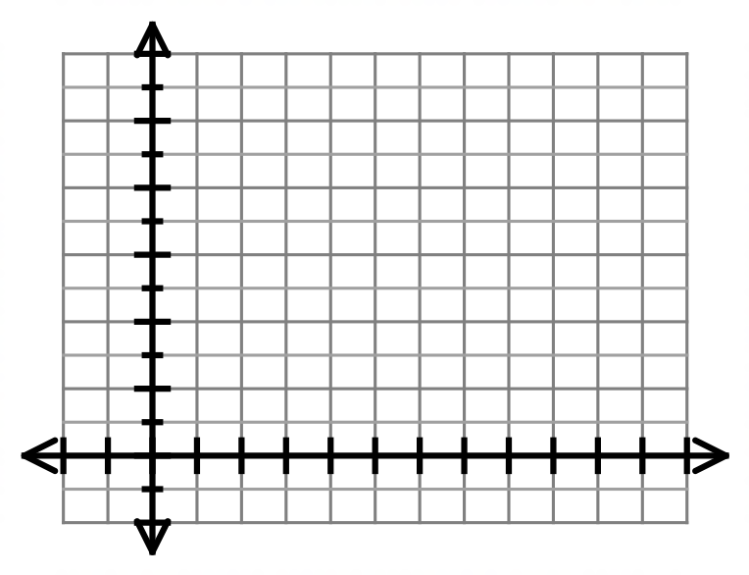

Question 11 (10 marks)

A survey of the 200 properties on a housing estate was undertaken. Part of the data collected related to the number of bedrooms and the number of toilets in each property as shown in the table below:

 |  | Number of toilets
 |  | 1 | 2 | 3 or more | Total
Number of  bedrooms | 1 | 35 |  |  | 35
 | 2 |  | 5 | 0 | 55
 | 3 | 5 | 65
 | 4 or more | 0 | 0 |  | 25
 | Total

(a) Complete the table. (2 marks)

(b) A property on the estate is selected at random. Find the probability that the property has:

(i) exactly 3 bedrooms. (1 mark)

(ii) at least two toilets. (1 mark)

(iii) exactly 3 bedrooms and at least 2 toilets. (2 marks)

(iv) at most 2 bedrooms, given that it has exactly 2 toilets. (2 marks)

(c) Three properties are selected at random from those that have exactly 3 bedrooms.
Calculate the probability that one property has 1 toilet, another has 2 toilets and
the third property has at least 3 toilets. (2 marks)

Question 12 (7 marks)

A sector OPQ of a circle with centre O is drawn below. The radius of the circle is 18 cm and angle POQ is 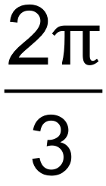 radians. The tangents to the circle at the points P and Q meet at point R. 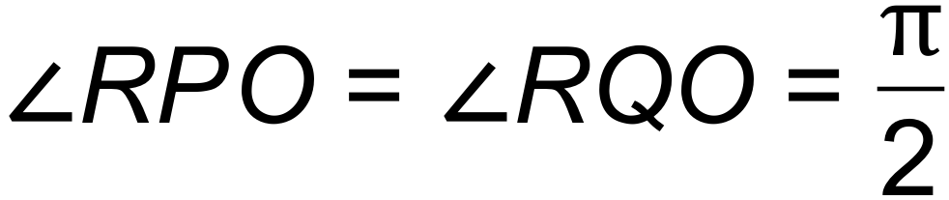

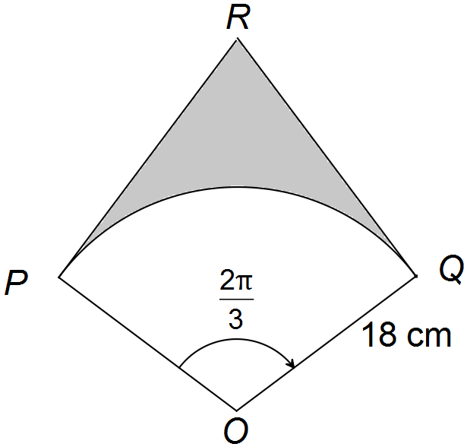

(a) Determine the exact length of arc PQ. (2 marks)

(b) Find the exact value in radians of 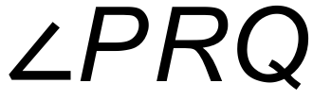. (1 mark)

(c) Find the exact area of the shaded region. (4 marks)

Question 13 (7 marks)

The circle with centre A(5, 8) touches the 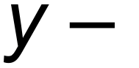axis as shown below.
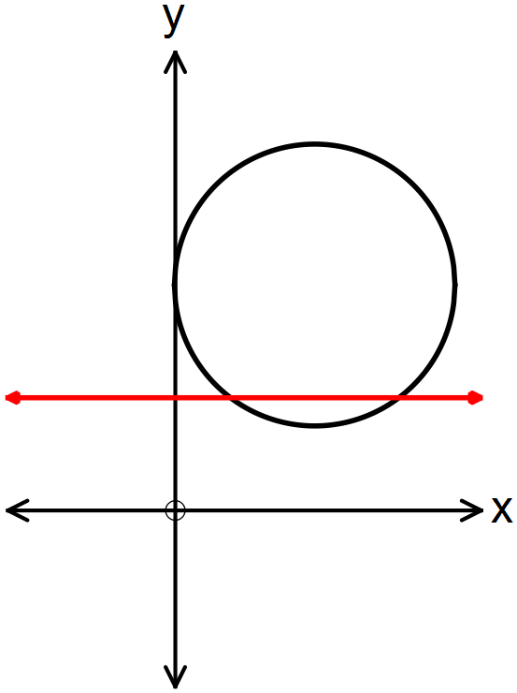

(a) Show clearly that the equation of the circle is 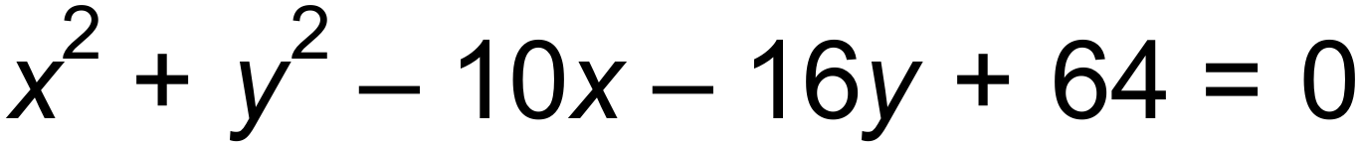. (2 marks)

(b) The line 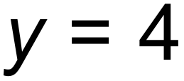 intersects the circle at point M and N.

(i) Determine the length of the chord MN. (2 marks)

(ii) Find the area of the minor segment formed between MN and the circle. (3 marks)

Question 14 (7 marks)

An experiment consists of drawing a number at random from 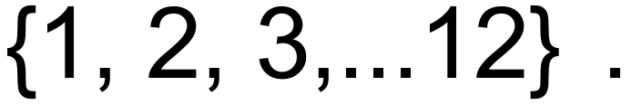
Event A is the set of even numbers and event B is the set of prime numbers.

(a) Determine the following probabilities:

(i) 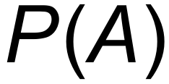 (1 mark)

(ii) 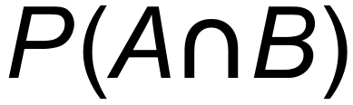 (1 mark)

(iii) P(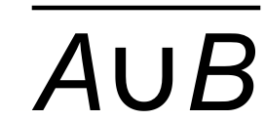 ) (1 mark)

(b) Show that events A and B are not mutually exclusive. (1 mark)

In the same experiment events C and D are independent with 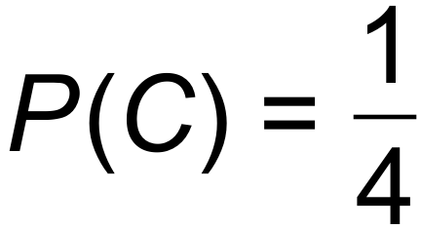 and 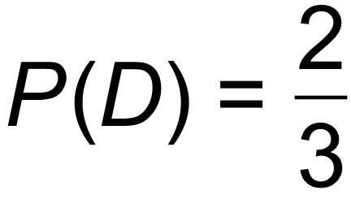.

(c) Find:

(i) 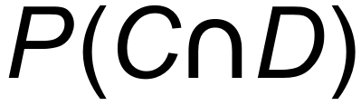 (1 mark)

(ii) 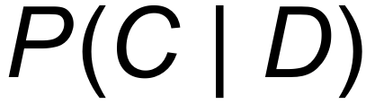 (1 mark)

(iii) 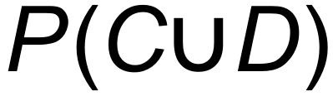 (1 mark)

Question 15 (6 marks)

Melissa is on her stand−up board and paddles from a buoy on a bearing of 016°T for 20 minutes at a speed of 4.2 km/hr. She then changes course and paddles on a bearing of 102°T for a further 430 m.

(a) How far is she from the buoy where she started? (3 marks)
(Draw a diagram.)

(b) What bearing must she take if she wishes to return directly to her starting position? (3 marks)

Question 16 (10 marks)

In a group of Year 11 students, 60% are girls and 40% are boys. 35% of the students are taller than 172 cm. The probability that a boy is taller than 172 cm is 0.206.

(a) Complete the Venn diagram below. (3 marks)

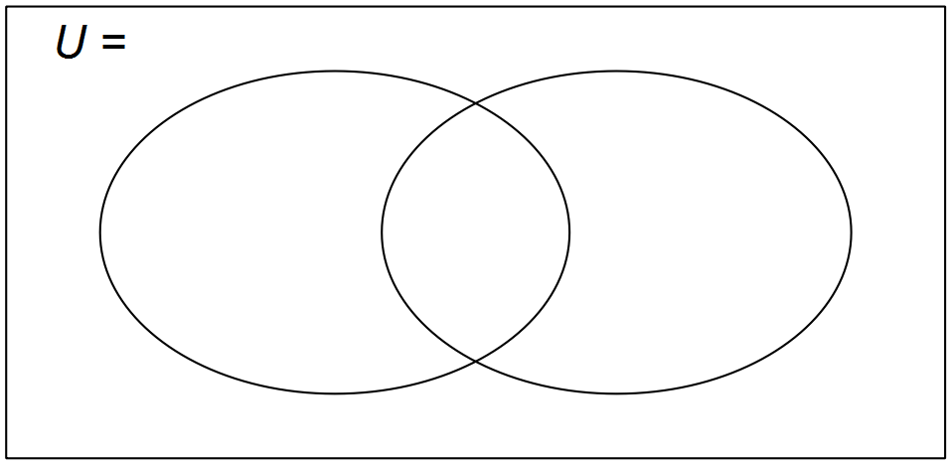

(b) A Year 11 student is selected at random. Find the probability that:

(i) the student is a girl taller than 172 cm. (1 mark)

(ii) the student is a boy less than 172 cm. (1 mark)

(iii) a student is taller than 172 cm, given that the student is a girl. (2 marks)

(c) There are 265 students in Year 11.
State the ratio of the number of girls over 172 cm to the number of boys over 172
in the form 1: k where k is rounded to 3 significant figures.
(3 marks)

Question 17 (6 marks)

The diagram below has an arc, PQ, of a circle with centre O and radius r.
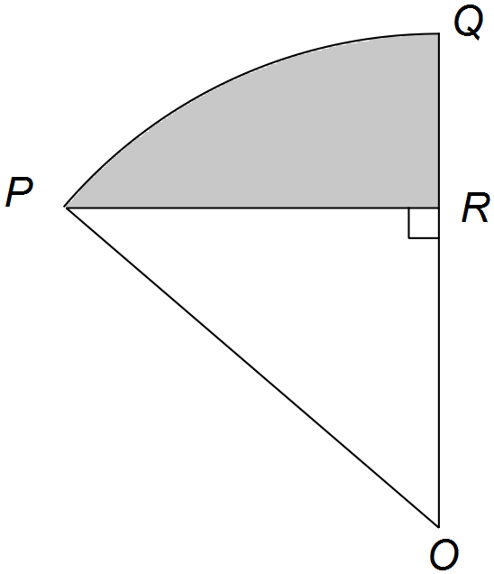PR is perpendicluar to OQ. Angle POQ = 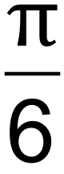 radians.

(a) Show that the area of triangle POR= 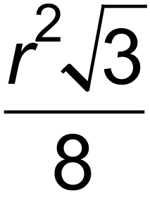 in terms of r. (3 marks)

(b) If the shaded area is 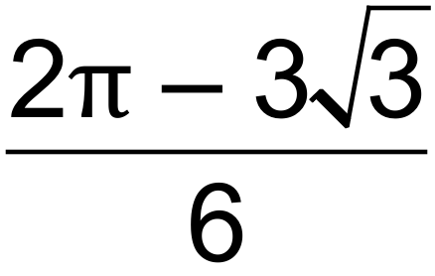 cm², calculate the value of r. (3 marks)

Question 18 (9 marks)

Jerome saves his favouirte digital images on his tablet in three separate folders, namely “Family”, “Friends” and “Travel”. His Family folder contains 3 images, his Friends folder contains 4 images and his Travel folder contains 8 images. All the images are different.

(a) (i) How many ways can Jerome arrange the 15 images in a row across the computer screen before they are put into the folders? (1 mark)

(ii) Jerome chooses 2 images from each folder to use as background images. How many different selections of background images are there? (2 marks)

(iii) Calculate the probability that if Jerome chooses 6 images at random, there are two from each folder. (2 marks)

Jerome chooses a further 7 favourite images and draws the following Venn diagram:

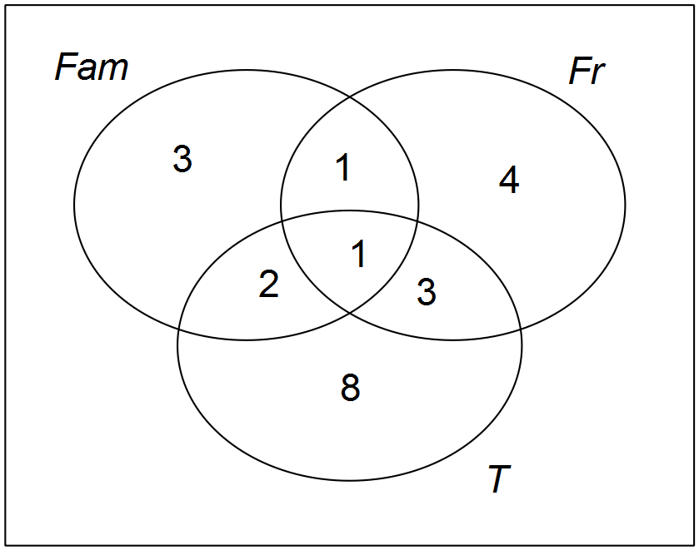

(b) (i) Shade in the area  and explain its significance in this context. (2 marks)

(ii) Given that an image was taken when travelling, what is the probability that it had friends in it? (2 marks)

Question 19 (8 marks)

The graphs of eight functions are shown below.

A. B. C. D.
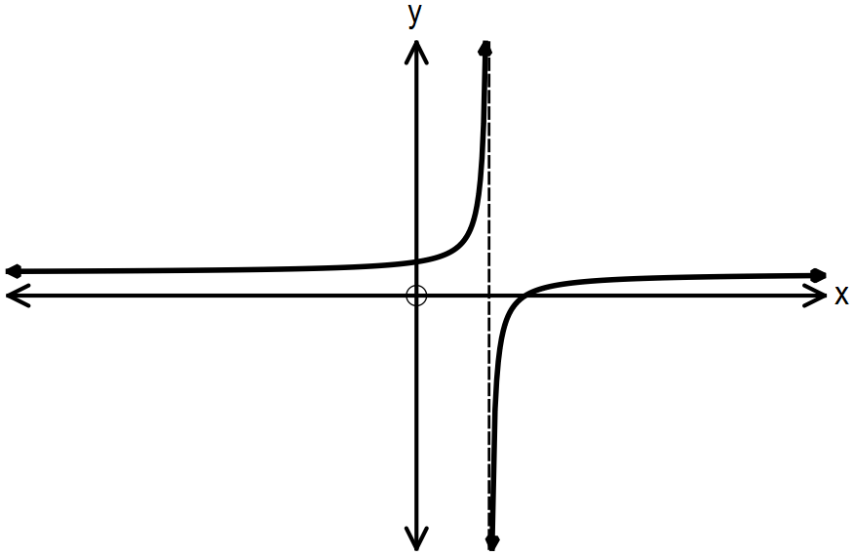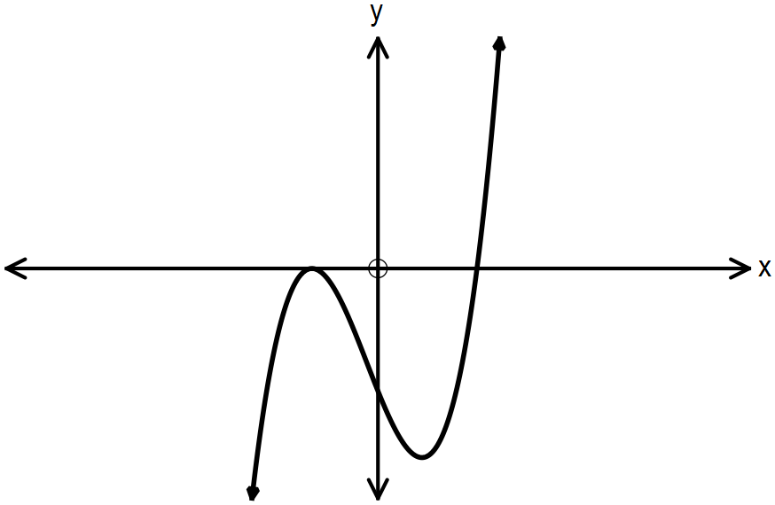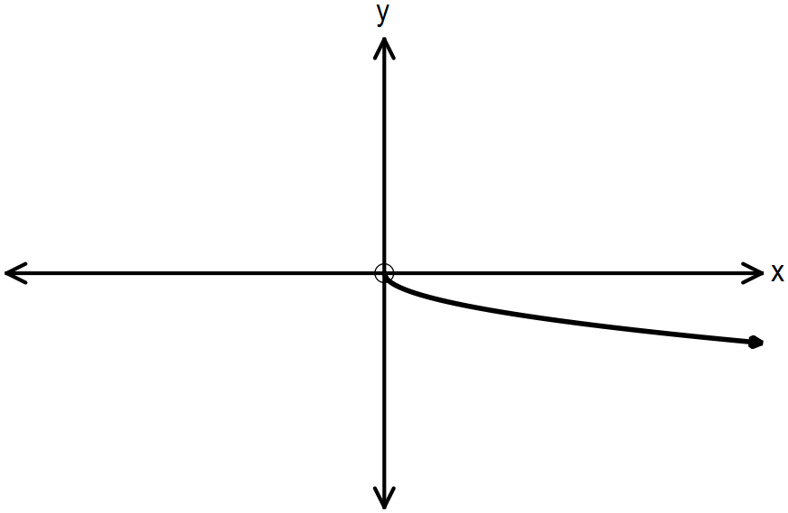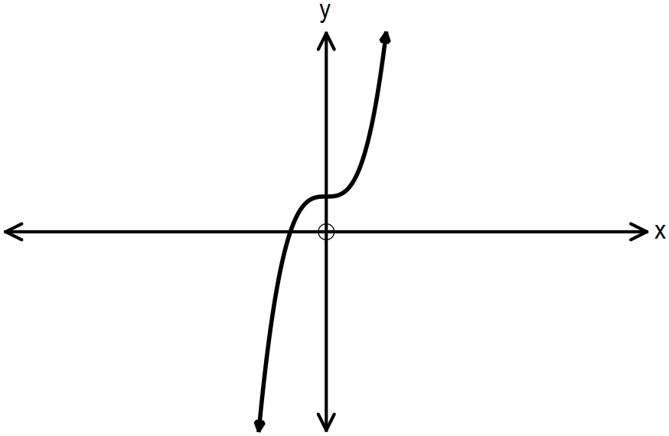

E. F. G. H.
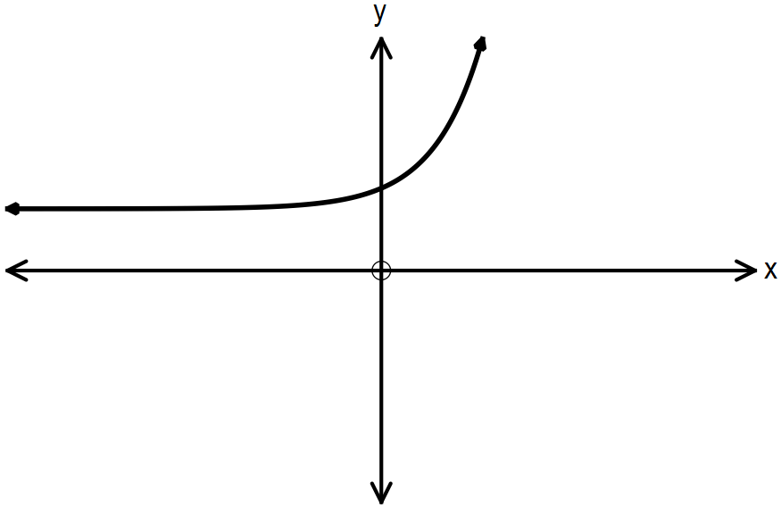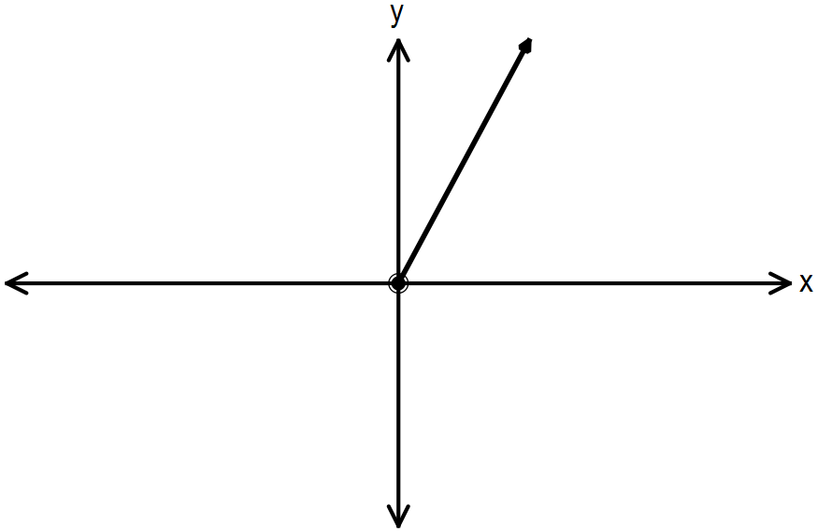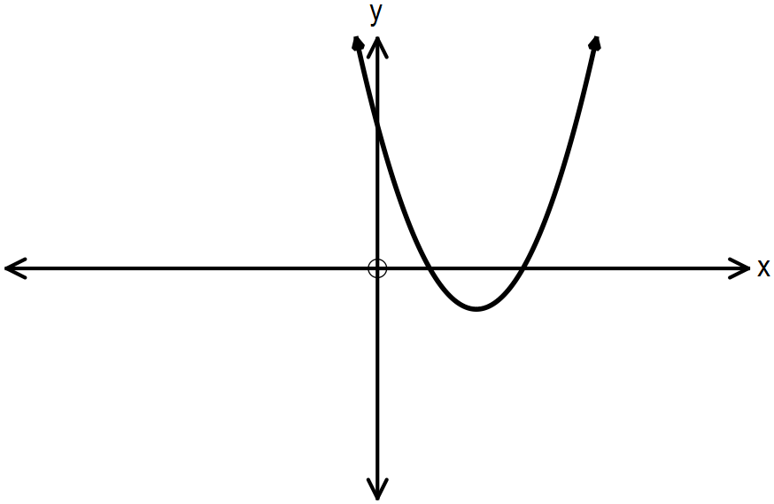
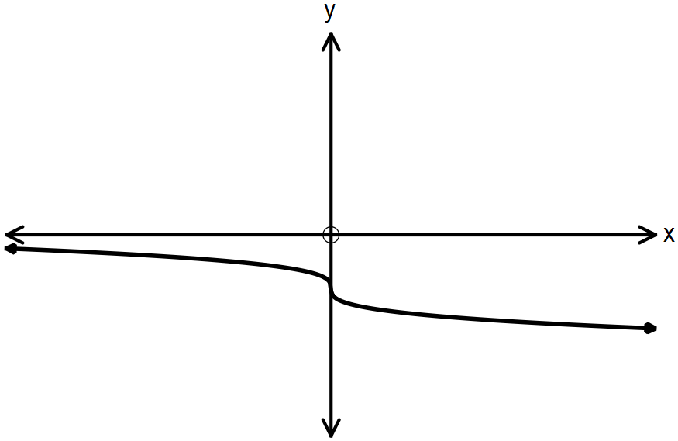

Identify the graph(s) that:

(a) has/have horizontal asymptotes. (1 mark)

(b) has/have only positive domains. (1 mark)

(c) has/have a positive constant gradient. (1 mark)

(d) represent(s) direct variance. (1mark)

(e) is/are in the form 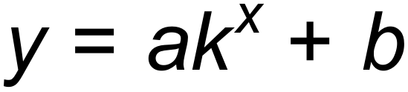. (1 mark)

(f) pass(es) through quadrants I, II and III only. (1 mark)

(g) has an axis of symmetry 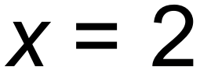. (1 mark)

(h) has/have a degree of 3. (1 mark)

Question 20 (6 marks)

The probability that Hannah goes swimming on any given day is 0.2. On a day that she goes swimming the probability that she has a burger for dinner is 0.75. On a day when she does not go swimming, the probability that she has a burger for dinner is x. The probability that Hannah has a burger for dinner on any day is 0.39.

(a) Determine the value for x. (2 marks)

(b) Given that Hannah had a burger for dinner, find the probability that she went
swimming that day. (2 marks)

(c) Are the two events “having a burger” and “goes swimming” independent?
Justify your answer mathematically. (2 marks)

Question 21 (9 marks)

(a) (i) The radius of a sphere is 15 cm. Determine the exact volume of the sphere. (1 mark)

(ii) The volume of a sphere is directly proportional to the cube of its radius. Using the information above in (i) show that the value of the constant of proportionality is 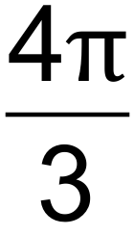 .
(1 mark)

(iii) Determine the angle of inclination between the graph of the direct variance function 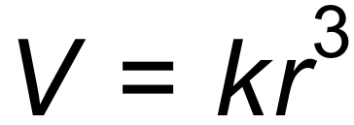 and the positive r³ – axis. (2 marks)

(b) The area of a room is 20m². If the length is increased by 3m and the width is increased by 1m, the room will double in area. Formulate a quadratic equation, and hence determine the original dimensions of the room. (3 marks)

(c) State the domain and range of the function 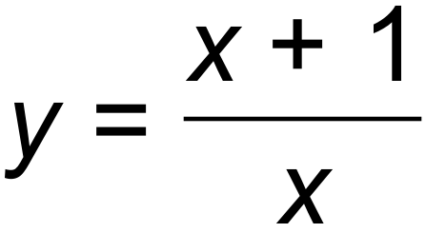. (2 marks)

Question 22 (6 marks)

Sound waves can be modelled on sinusoid functions. The following graphs were drawn after experiments with sound waves were conducted.

A: Quieter B: Louder
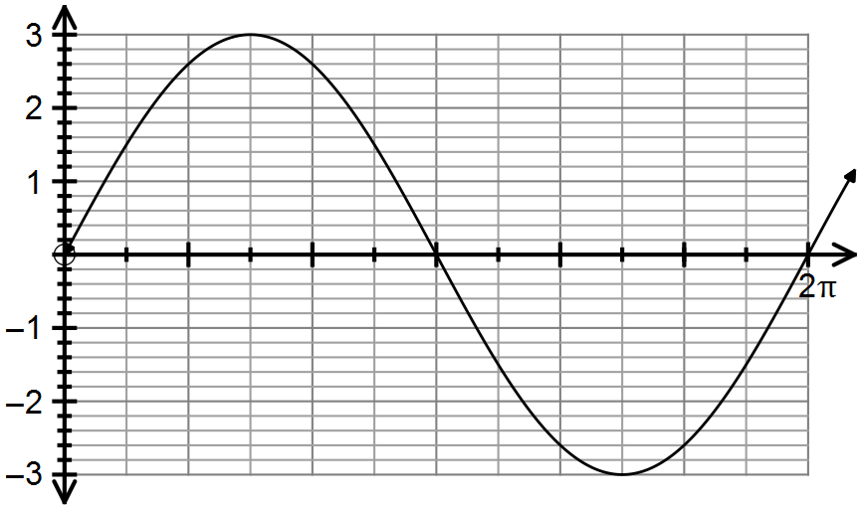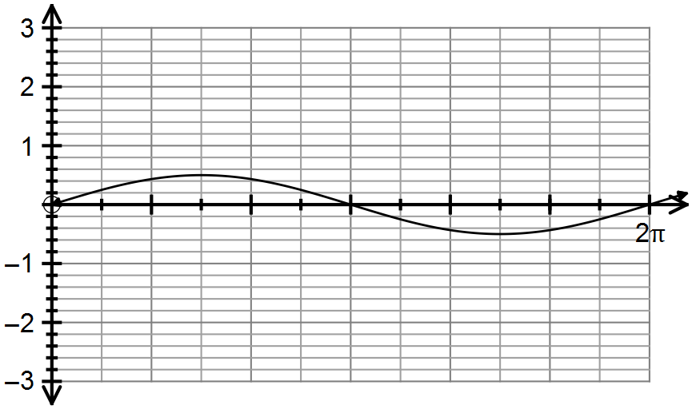

C: Deeper pitch D: Higher pitch
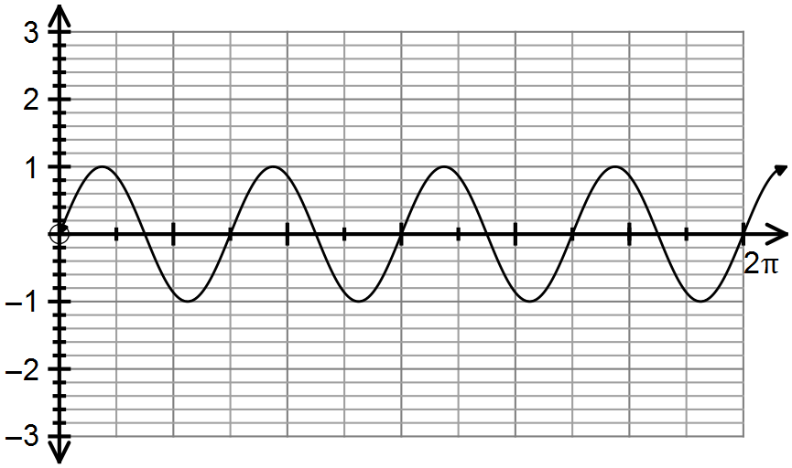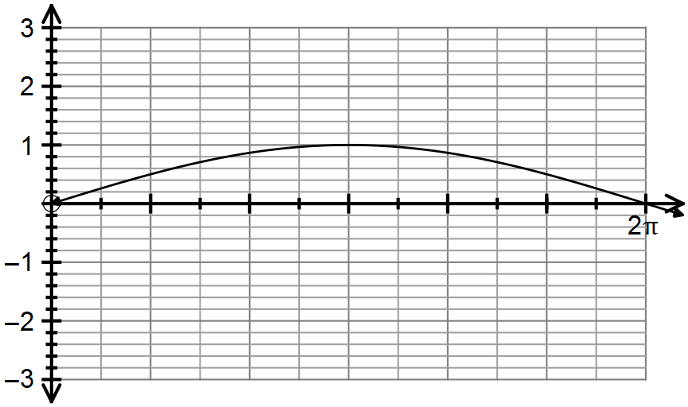

State the equation of each graph and discuss the changes in amplitude and period to achieve the different sounds.

End of Questions
Additional working space

Question number(s): ……………………

Additional working space

Question number(s): ……………………

